Rensselaer Mechatronics

Lab 4 Submission: Feedback Control

Objective
Practice the entire process of feedback control design for a simple system including modeling, control design, and testing.

Introduction
For this assignment, you will work with the online game used in class to simulate the positioning stage for a semiconductor inspection system. Your objective will be to design a compensator to control the position of the stage. The instructions will be minimal, with some hints – you will need to consider what you learned in previous labs and classes to solve the problem. To get started, go to the link, http://labineering.com/CC/ and open Tutorial #1.

Part 1: Modeling
In class, you tested different control parameters (i.e. PID gains), using trial and error with somewhat vague performance goals. In this assignment, you will design a control law based on theory to achieve specific performance objectives. To do this you first need a model (transfer function) of the system.
Consider the physics of the system, as you did with the DC motor in Lab 2. This will inform what type, or order, of model is appropriate. The positioning stage can be simplified as a mass translating with friction. Assume there are no spring-like behaviors that affect the motion of the stage. A force is applied.
- Draw a free body diagram of the positioning stage
- Derive the ordinary differential equation that describes the position of the stage
- Obtain two transfer functions: one from force to position, and one from force to velocity
- Notice that both transfer functions have the same unknown physical parameters (e.g. mass). Re-write your two transfer functions in terms of a steady state gain $K$, and a time constant $τ.$
Show all your work here to derive the transfer functions
With a first order system, you can use the same “black box” experiment as you did in Lab 2 to determine the transfer function parameters. Design an experiment to determine the transfer function parameters for the positioning stage system.

The code below shows you how to obtain data from the system simulated in the game.
In Tutorial #1, cut and paste the following SAMPLE code:
function controlFunction(Stage)
{
Log_Sim_Data(Stage); // Log Signals

return 5*Math.sin(10*Stage.T); //input command signal
}

You have to refresh your browser to log new data. You can save the printed data by pausing the game, selecting and copying the variable(s).
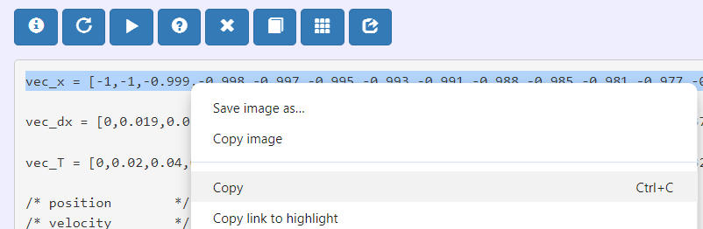
Then, paste it into a MATLAB editor:
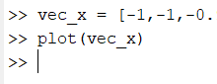
Modify the code appropriately so you can obtain the experimental data you need to identify the transfer function of the system. Again, this problem statement is intentionally open-ended to make you think; here are some hints:
- The code above is given to you as a sample to show you how to store and save data. Do not assume anything in the sample code is what you actually need. You need to determine what data you need to do with the data.
- Consider the transfer function you derived from physics above, review Lab 2, and also In-Class 4 question 2.2
- The sample time is 0.015 seconds.
Using the experimental data, compute the appropriate transfer function parameters. Show your work, including any plot used to compute transfer function parameters.
You must mark your plots with Data Tips that show the exact points you will use for your calculation. You will not receive credit for this part if you do not show the exact data points, and use them in your shown calculations:
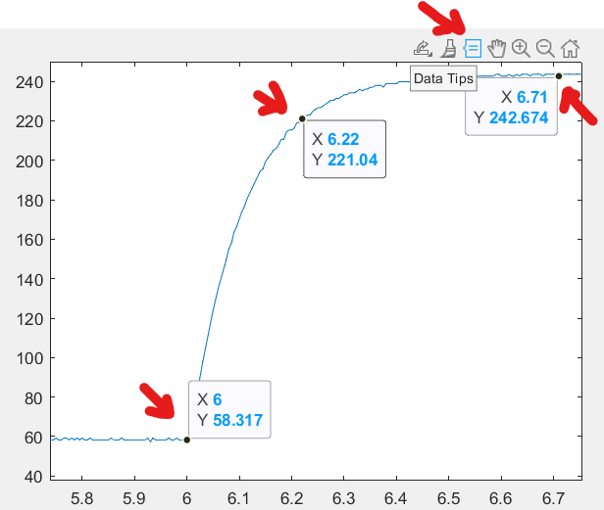
Include screenshots of your plots, work, and game code used to obtain your experimental data.
[ Annotated Plots with Data tips used and all work and code showing calculations of K, $τ$
Finally, verify your transfer function model makes sense by plotting the simulated response on top of the experimental data (see Lab Submission 2 for reference). Your simulated transfer function response should almost exactly match your experimental data. Include screenshots of your plots, and code.
[ Annotated Plots and all code ]

Part 2: Proportional Control Design
In this section, you will use the model in the previous section to design a proportional controller for the system using the equations for the closed loop feedback system. Use the following steps:
- Draw the block diagram of the closed loop feedback system with a proportional gain and the appropriate transfer function for the position of the block.
- From this block diagram determine the closed loop system transfer function (Hint: recall Prelab 4)
- From the closed loop transfer function determine expressions for $ω_{n}$ and $ζ$. (Hint: Your closed loop transfer function should be a second order system. Review material about second order systems will be posted on Blackboard).
- Solve for the proportional gain that will result in a system with 25% overshoot.
Show your work here:
Block diagram, closed-loop transfer function, $ω_{n}$ $ζ$, proportional gain

Part 3: Testing the controller
In this section, you will test your value of the proportional gain on the actual system from the game. Record the response and plot it on a graph. Clearly indicate the data point on your graph and calculate the % overshoot that is achieved. Comment on how the overshoot in the experiment compares to the designed overshoot – it should match well. Include a screenshot of your game code used to obtain your desired control response.
Annotated Plots with Data tip and code

